Border
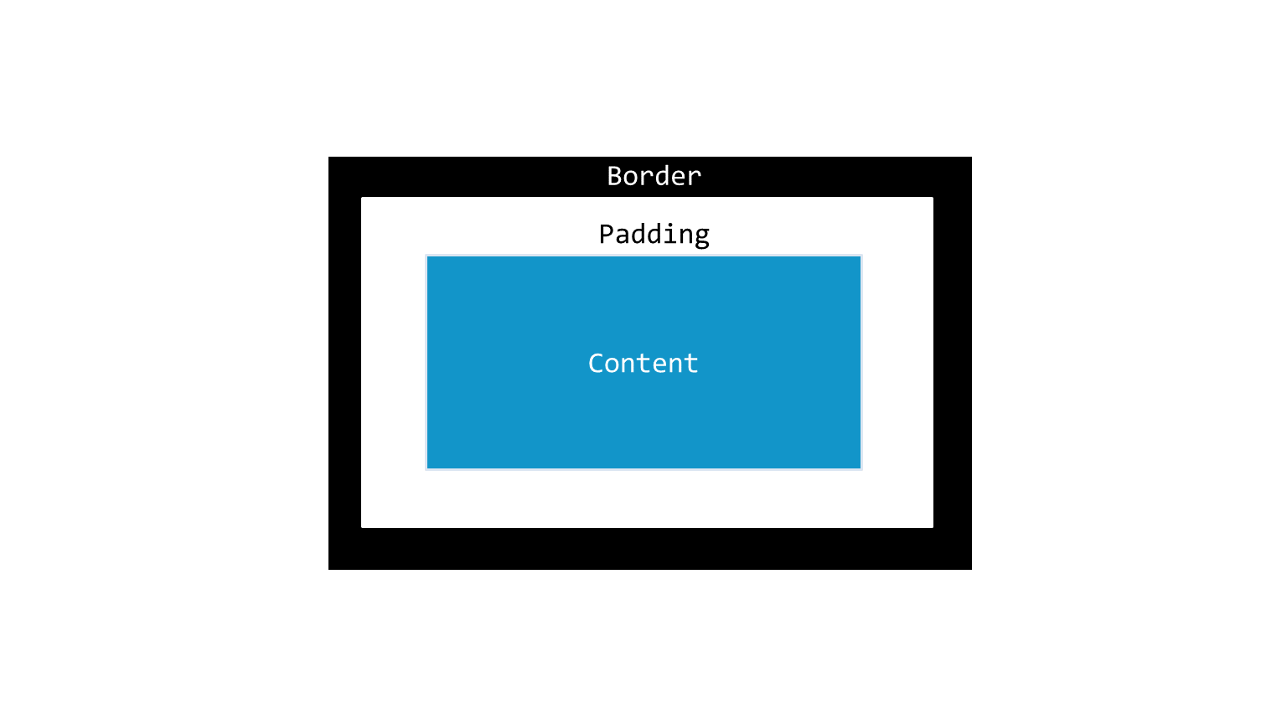
- Border marks the ending of the element and depends on the height and width. It is present around the padding on all the four sides. Because of the initial default values, the border is transparent

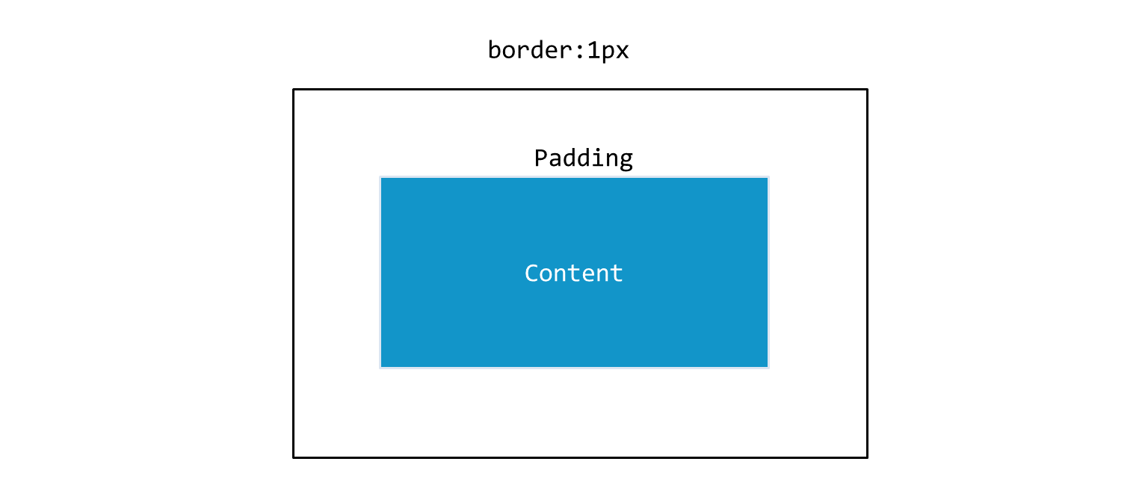
- We use the shorthand CSS property called border to set individual border property values such as width, style and color for styling the border around the padding. This is how we use border shorthand property: border: 1px

Here we are instructing the browser to set the border width to 1px and the border style and color are set to the default values.
- Just like padding we can set border styles on any side of your choice using border-top, border-left, border-bottom, border-right properties.You can use these in combination also, example if you want to set the border to 5px on right and border to 15px on the bottom you can do it by writing
  - border-right: 5px;
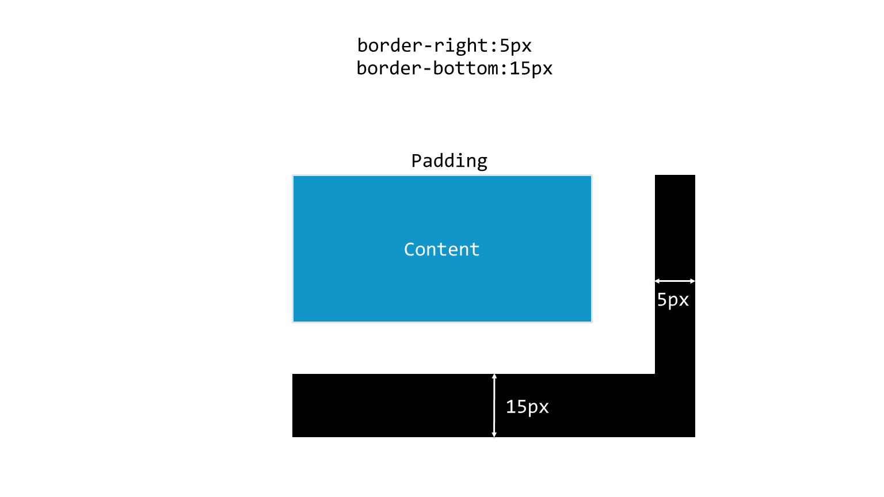
  - border-bottom: 15px;

- You can also mention this in a single line using shorthand property like this border: 0px 0px 15px 5px;
